**User Program Features Guide Sheet**

**Home Hub Page. This is the landing page for the web application. It leads to the customer portal, employee portal, the store, and for non customers to create a new account.**

**The Search page or the Store. Is where customers and non-customers will shop our inventory. They can hit Add to Cart Button below to add item to the shopping cart at the bottom of the page.**

**Checkout Shopping Cart functionality is at the bottom of the store page. Customers can change the quantity of an item and remove an item from the cart.**

**After a Non-Customer hits the Order button, they’re redirected here to the payment page for Non-Customers. Since they’re not a customer, we do not have their info needed to accept the order just yet. *Note Customers will not be redirected to this page, because we have their account information already.**

**Before or after a Non-Customer orders something, they may click on the Create Account link to create a new Customer Account with TeamSix Coin Company. *Note if an order is placed before becoming a member, their order will not show up in view orders as customer.**

**The Customer Login Portal is used for their Login Creditials. If they forgot their password they can click on forgot link, to send an email to reset account password. Note* these loggins can be found in the DB**

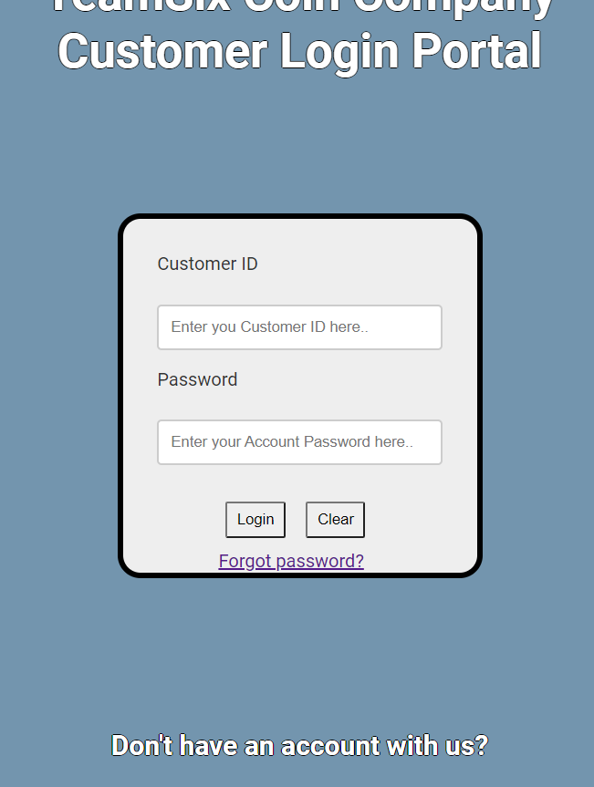

**When a Customer has succesfully logged in. They’re brought to the info page. The info page currently offers these features for customers. They can view Open/Shipped orders from the company. Also can edit account information, and shop the store to place an order.**

**If a customer wants to update account, they’re brought to the update page like below. They can then edit everything in their account profile, besides the Customer ID.**

**The Processor Login portal is similar to the Customers, but for employees. If an employee has forgotten their password they can reset with the forgot password link. Note* these loggins can be found in the DB.** Graphical user interface, application

**When a Processor or Employee has succssfully logged in. They’re currently offered two features. They can view all shipped orders from the company, or can view all open orders that still need processing.**

**The Open ordering page looks like below. Processors can change the status, log the Date of Approval, and add Approver ID. *Note if they forget to Log their ID and Date the system will automatically update the DB with who approved and current date.**

